Lab Assignment 5

Machine Learning

Name: M Jeyapathy

USN: 22BTRAD016

**1.Implementing Logistic Regression algorithm**

import pandas as pd

from sklearn.model_selection import train_test_split

from sklearn.linear_model import LogisticRegression

from sklearn.metrics import accuracy_score, confusion_matrix

# Reading the CSV file

data = pd.read_csv('your_file_path.csv')

# Assuming 'Age' and 'Income' are the features and 'Loan_Approval' is the target variable

X = data[['age', 'income']]

y = data['Loan_approval']

# Splitting the data into training and testing sets

X_train, X_test, y_train, y_test = train_test_split(X, y, test_size=0.2, random_state=42)

# Creating a logistic regression model

model = LogisticRegression()

# Training the model

model.fit(X_train, y_train)

# Making predictions on the test set

y_pred = model.predict(X_test)

# Calculating accuracy

accuracy = accuracy_score(y_test, y_pred)

# Displaying confusion matrix

conf_matrix = confusion_matrix(y_test, y_pred)

print(f"Accuracy: {accuracy}")

print("Confusion Matrix:")

print(conf_matrix)

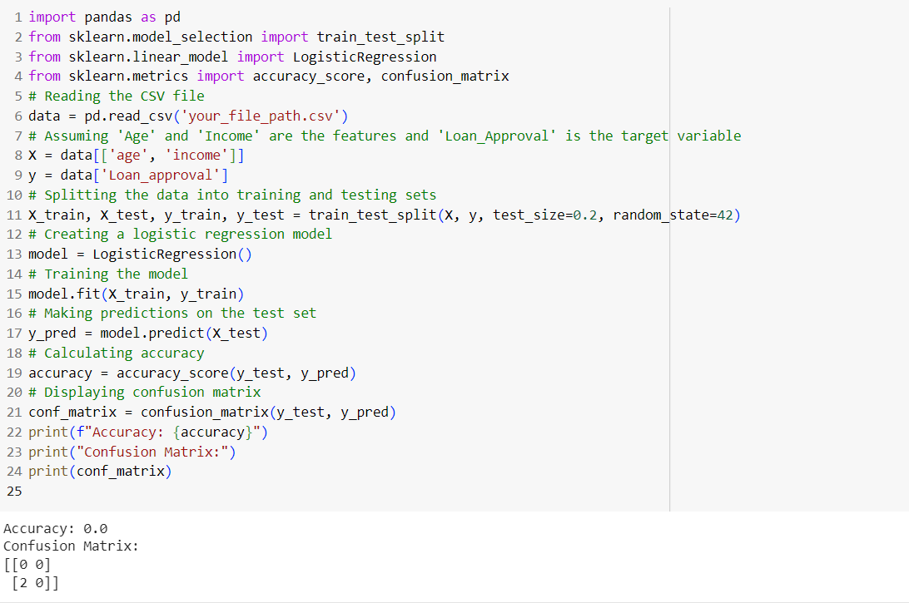

This code reads the data, splits it into training and testing sets, trains a logistic regression model, makes predictions, and prints accuracy along with a confusion matrix.

we import necessary libraries:

* **pandas**: For data manipulation and analysis.
* **train_test_split**: To split the dataset into training and testing sets.
* **LogisticRegression**: Implementation of logistic regression from scikit-learn.
* **accuracy_score** and **confusion_matrix**: Metrics to evaluate the performance of the model.

Logistic Regression is a statistical method used for modelling the probability of a binary outcome. Despite its name, it's commonly employed for classification tasks rather than regression. The algorithm predicts the probability that an instance belongs to a particular category.

Logistic Regression is a foundational algorithm in machine learning and is particularly useful when dealing with binary classification problems.

**GITHUB LINK: https://github.com/Jeyapathy/Machine-Learning**